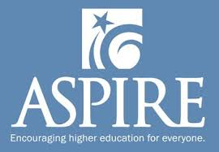

ASPIRE is for all students at Wilsonville High School.

ASPIRE is the state of Oregon’s mentoring program to help students access education and training beyond high school.

ASPIRE matches students with volunteers to help them develop a plan for after high school.

* EXPLORE career and educational options
* RECEIVE assistance with essays and applications
* APPLY to the program(s) of choice
* CHOOSE the best fit
* PAY for the program (identify scholarship and financial aid resources)

ASPIRE will help a student get to where they want to go!

Interested students should see Lyndi Tucker in the College & Career Center!

**Volunteer!**

ASPIRE mentors are members of the Wilsonville community who volunteer their time to assist our students. They are trained and background-checked, and truly want to help students succeed. Mentors are asked to commit to, but are not limited to, at least one full academic year. Students and mentors are matched for at least one year (and often longer!).

Student-Mentor meetings take place during the school day in the College & Career Center. The meetings last no longer than 20 minutes and occur at a mutually agreed upon time, as frequently as is necessary.

Interested in volunteering? Contact Lyndi Tucker for more information.

Lyndi Tucker  
WHS College & Career Coordinator/ASPIRE Coordinator  
[tuckerl@wlwv.k12.or.us](mailto:tuckerl@wlwv.k12.or.us)  
(503)673-7628